

SYLLABUS
COLLEGE OF COMPUTING AND SOFTWARE ENGINEERING
SWE 4713 – SOFTWARE APPLICATION DOMAIN

Fall 2025

Course Information

Class meeting time: TTH 5:00PM – 6:15PM
Modality and Location: Face to Face course; Atrium Bldg., Room 216
Syllabus is posted in D2L

Instructor Information

Name: Dr. Jerry Mamo
Email: emamo@kennesaw.edu
Office Location: Marietta Campus, Atrium Bldg., J353D
Office phone: 470-578-5618
Office Hours: TTh 6:15PM – 7:45PM
Preferred method of communication: KSU email

Course Description

Students work as part of a team to develop solutions to problems posed by either internal or external customers in a specific SWE Application Domain. The purpose of the course is for the student to gain an understanding of the selected application domain, and its use of software to support functions/operations within that domain. Application domain selection is done every term from a variety of industrial domains including Security, Gaming, Automotive, Aerospace, Military, Finance and Commerce. Problems may require considerable software development or evolution and maintenance of existing software products. The course culminates with the completion and presentation of an increment of the project solution.

Prerequisite: Three of these four: SWE 3623, SWE 3633, SWE 3643, SWE 4324, SWE 4663.

Course Materials

Required Texts: No textbook.
Recommended Texts: Accounting Principles, 12th Edition, Jerry J. Weygandt, Paul D. Kimmel, Donald E. Kieso
Technology requirements: Computer with internet access, software development IDE, database, project progress tracking tool, e.g. Trello.

Course Learning Outcomes

- Describe basic accounting and finance techniques used by management.
- Discuss the relationships between manual and computerized accounting applications.
- Use software as a tool for solving accounting problems.
- Apply practical accounting skills for business problem solving through the creation of accounting application using a web programming language of students' choice and a database.
Course Requirements and Assignments

 | Item |  |  | Description |  |  | Session |  |  | Comments
1 |  |  | Review the syllabus, explain course strategy, and provide course overview. |  |  | (8/18) |  |  | Introduction Discussion
2 |  |  | Discuss users of accounting data. Discuss GAAP Principles and their importance in accounting. Discuss measurement principles. |  |  | (8/20)
3 |  |  | Sep 1 |  |  | Labor Day |  |  | No class
4 |  |  | Discuss the accounting equation and its components – assets, liabilities, and equity. Analyze the effects of business transactions on the accounting equation. Discuss the importance of the chart of accounts. |  |  | (8/25) |  |  | Class Exercise 1
5 |  |  | Describe the four financial statements generated out of the accounting record keeping process – income statement, owner’s equity, balance sheet, and statement of cash flows. |  |  | (8/27) |  |  | Class Exercise 2
6 |  |  | Describe how debits and credits are used to record transactions. Indicate how a journal is used in the recording process. Discuss chart of accounts and their importance. Solve assignment 1. |  |  | (9/2) |  |  | The Recording Process.
7 |  |  | Review journalizing concepts. Discuss Accounting Software Database Design Considerations. Review requirements for accounting software. |  |  | (9/4)
8 |  |  | Review solved problems used for testing software. Discuss design implications |  |  | (9/8)
9 |  |  | Discuss chart of accounts design |  |  | (9/10) |  |  | Class Exercise 3

 | considerations.  Explain how a ledger & posting are used in the recording process. Discuss how ledgers and the posting process should be handled in accounting software. |  | Class Exercise 4
10 | Discuss the steps in the recording process. | (9/15)
11 | Discuss user interface design considerations for the accounting software. Review sample user interface designs. Review sample accounting software. Review sample financial statement designs. Review sample ratio analysis designs. Review sample dashboard designs. | (9/17)
12 | Accounting Software Proposal presentation | (9/22)
13 | Discuss Trial Balance, limitations of a trial balance, and locating errors on the trial balance. Discuss how trial balance is generated and presented in accounting software. | (9/24) | Read material on the preparation of financial statements found under the references section.  Test 1
14 | Discuss the difference between fiscal and calendar years, accrual versus cash basis accounting. | (9/24) | Class Exercise 5
15 | Discuss recognizing revenues and expenses, the need for adjusting entries, and types of adjusting entries. | (9/24) | Class Exercise 6
16 | Discuss project backlog | (9/29)
17 | Project Demonstration 1 | (10/1)
18 | Project Demonstration 1 | (10/1) | Feedback will be provided based on the latest software demonstration.
19 | Discuss deferral accounting, prepaid expenses, and unearned revenues. | (10/3)
20 | Discuss how to prepare adjusting entries for revenues and expenses. Discuss how adjusting entries are handled in accounting software. | (10/6)
22 | Project Demonstration 2 | (10/13) | Feedback will be provided based on the latest software demonstration.
23 | Discuss how to prepare adjusting entries for accruals. | (10/15)
24 | Discuss how to prepare adjusted trial balance. Discuss closing entries. Discuss how closing journal entries are handled in accounting software. | (10/20)
25 | Project Demonstration 3 | (10/22) | Feedback will be provided based on the latest software demonstration.
26 | Discuss how to prepare financial statements, closing entries, and post-closing trial balance. Discuss how financial statements are generated and presented in accounting software. | (10/27)
27 | Review & groom project backlog | (10/27)
28 | Discuss the difference between manual and computerized accounting systems | (10/29)
29 | Project Demonstration 4 | (11/3) | Feedback will be provided based on the latest software demonstration.
30 | Discuss Financial Statement analysis. Discuss how financial statement analysis is handled in accounting software. | (11/10)
31 | Project Demonstration 5 | (11/17) | Feedback will be provided based on the latest software demonstration. Your software should be almost ready by this date. It should only require minor changes, if any.
32 | Discuss how and why ratio analysis/dashboards are used. | (11/17)
33 | Final Project Presentation | (12/2) | Please hand in a copy of the software, design document, meeting minutes and testing documents in flash drive and submit in the folder provided in D2L whichever you prefer.
34 | Final Project Presentation | (12/4)

Evaluation and Grading Policies

List any grading policies. You must include a statement on feedback expectations and feedback turn-around time. Explain how grades are to be earned; if extra credit is offered, it should be included (and available to all students). Be sure to include an evaluation scale. The one below is just one example.

Your raw score will be obtained by a weighted average as follows:
No Final Exam

Test 1 15%
Team evaluation 10%
Documentation 15%
Project Presentation 1 5%
Project Presentation 2 5%
Project Presentation 3 5%
Project Presentation 4 5%
Project Presentation 5 5%
Final Project Presentation 6 & documentation 25%
Project quality (Professor’s discretion) 10%
Note that the project quality of each team will be compared and the professor will assign a grade based on the observation made during final project presentations.
The following grading scale will be used:
GRADING SCALE:
89.5% - 100% A
79.5% - 89.4% B
69.5% - 79.4% C
59.5% - 69.4% D
0% - 59.4% F
I will round up grades if they are > or = .5 or above, for example, an 89.6 is an A, but 79.2 is a C.

Optional Text – Faculty are strongly encouraged to participate in one of the following processes to communicate a student's progress in a course. Choose the statements below that best fit your course.

Early Alerts/Progress Reports: This class is participating in Early Alerts, which faculty will submit during the first few weeks of class. These reports notify advisors and student success coaches to a range of things like missing class, missing assignments, if you might need to visit tutoring, or could benefit from help with time management or study skills. These are not recorded as grades and are meant to provide you with some additional resources to ensure you can be successful in your class. If you receive notification of an early alert, please take advantage of these resources.

Midterm Grades: A midterm grade may be assigned by the midterm grade due date identified on the academic calendar. This midterm grade is for assessing mid-semester performance at least one week prior to the last day to withdraw without academic penalty. You may view your midterm grade in Owl Express. Note that only your final grade will be officially recorded on your academic transcript.

Course Policies

Attendance Policy
Must include course attendance policy. May include policies for late work, missed exams, extensions, excused absences, instructor expectations, etc.

- Face-to-face students are required to attend each session.
- Students are responsible for all announcements and assignments made in class.
- Students are expected to do their own work for all assignments unless otherwise indicated by instructor. Group discussion and study of the assignments are permitted, but, when you begin to prepare your assignment to turn in, all collaboration must cease. If collaboration is suspected, the grade will be a 0. Multiple occasions of collaboration will earn you an academic dishonesty F for the course.
- All assignments are due AT MIDNIGHT on the day indicated.
- Late assignments will not be accepted.
- If a class is cancelled for any reason, any assignment due that day will immediately be due the next scheduled class period. Any topic or test scheduled for that day will occur the next scheduled class period.
- Class attendance and participation is expected. Meaningful & relevant discussion is encouraged.
- Students with disabilities. Students who believe that they may need accommodation in this class are encouraged to contact the counselor working with disabilities; visit http://sds.kennesaw.edu/
- All current Kennesaw State University policies will apply.

- Late Assignments. Normally, late assignments will NOT be accepted and a grade of 0 will be noted; however, partial credit is given for partial work; if you haven't finished by the due date, submit whatever you have done. If you have special circumstances, talk to the professor, preferably BEFORE the assignment is due.
- Missed tests/exams. Normally, there will be no make-up opportunities for missed tests, and a grade of 0 will be noted if you miss a quiz. If you have special circumstances, talk to the professor, preferably BEFORE the test.
- Cheating Unless otherwise noted, all work submitted for credit is expected to be the work of the individual student (or team, for team assignments). If you use somebody else's work or ideas (other than the textbook, notes and standard references), please specify what you used. If you are found to be violating the rules of academic honesty, the LEAST that will happen is that you will receive a zero in the assignment/quiz, and a letter will be sent to the dean of the CSE School, to be kept on your file
(and potentially assign other penalties, including dismissal from school). Notice the 0 on the assignment and the sending of the letter are not negotiable (as per CSE school policy) and are just the LEAST severe penalty. Depending on the situation, harsher penalties may be assessed.
Notice that collaboration for LEARNING is not only allowed but encouraged. However, unauthorized collaboration on completing an assignment is not. Except under special circumstances, nobody but yourself (or team members when applicable) should see any code, diagrams or text that you will submit. It is OK to explain concepts, but NOT ok to give or show your work to others. If you have any questions about whether an act constitutes cheating, please ask the professor BEFORE the act.
- Intellectual Property. Please be advised that according to SPSU policy by handing out your assignments you give SPSU all intellectual property rights to that work. Also, it is assumed that you will secure rights to any media or file you use as part of your assignments.
- Progress Grades In addition to your course final grade, I normally record two progress grades for each undergraduate student in each semester, an "early warning" grade (for undergraduates only) and a midterm grade. These are recorded in the BANNER system and are available to you. The purpose of these two grade reports is to help you assess how you're doing in time to make changes or get help if it looks like you may be heading for an unsatisfactory grade. Progress grades will not appear on your official transcript. If you need help, it is available. The best place to start is with me or with your assigned advisor. If you want to talk to me about your progress, please stop by during office hours, or call or write for an appointment outside office hours.
- ID for proctored exams At proctored exams, you will be asked to take identification before the exam and have it ready. When you turn in your paper, you will also give me your photo identification. I'll compare the name on the ID to that on the paper, and the photo on the ID with the face of the person handing in the exam, then return the ID to you. Acceptable forms of identification are your Hornet Card, a driver's license, or any government-issued document with both your name and your photograph. Everyone will be treated alike, so you must present ID no matter how well I know you. If you come to class without an ID, you will be allowed to take the exam, but I'll make a note on your paper, and you will have to come by my office with a suitable ID prior to the next class period. I apologize for imposing this on each of you in this way, and I assure you that this new policy is no reflection upon any of you. Instead, it is intended to preserve the value of your SPSU degree in the
face of a very small number of people who would cheapen your degree by cheating their way through school. It is unfortunate that we have to do this, but it is necessary.
- Project. Each group of students will select a project which they will work on through the semester. It involves the design of a financial application that stores data either in a database or file and has, forms, reports and a switchboard for a 'real life' system of their choice.
- Project Ideas A handout will be provided with project ideas.
One key to a good grade in this course will be consistently doing the work on time.
This four-part mantra captures the essence of doing well in this class:
- Show up.
- Do the work.
- Collaborate with your team members
- Ask questions.
- Have fun.

Instructional Continuity Plan
Kennesaw State University (KSU) may decide to close campuses, operate on a delayed schedule, or transition to remote instruction for inclement weather or in case of emergency.
The University will announce campus closures, delayed schedules, or remote instruction through KSU Alerts sent to your cell number on file and to your university email account. In addition, announcements will be posted on KSU’s home page: www.kennesaw.edu.
Our class continuity plan includes:
- Communication: Please check D2l Brightspace or e-mail for necessary instructions.
- Virtual Classes: If in-person classes are not possible, we may transition to virtual classes using MS Teams.
- Assignments and Assessments: Deadlines for assignments and assessments may be adjusted to accommodate the emergency situation.

We understand that emergencies create unique challenges. If you need additional support during an emergency, reach out via Brightspace or e-mail. The university also offers resources such as counseling and academic support, which can be accessed remotely.

Policy on the Usage of Artificial Intelligence

AI Use Prohibited:
You are expected to generate your own work in this class. When you submit any kind of work, you are asserting that you have created it completely on your own unless you indicate otherwise using quotation marks and proper citation for the source(s) you used to help you. Submitting content that has been generated by someone other than you, or that was created or assisted by an AI generative tool is cheating and constitutes a violation of the KSU Code of Academic Integrity.

Department or College Policies

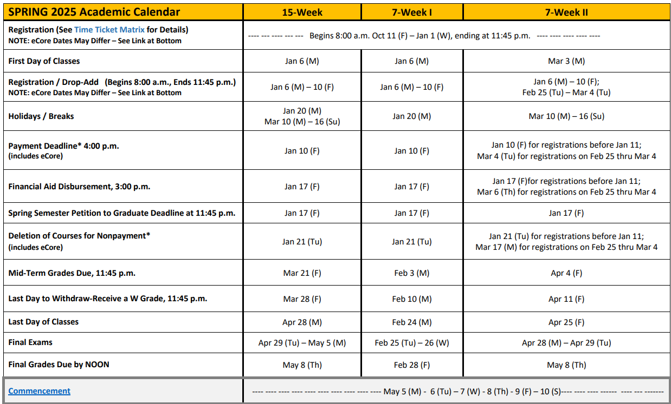

Institutional Syllabus Policies, Procedures, and Resources

Federal, BOR, & KSU Required Syllabus Policies and Student Resources

